- When we have many hidden layers, how do we increase the speed of training?
  - Weight initisalisation technique.
  - Batch Normalisation.
  - Activation function.
  - Optimizers, by using this how do we introduce speed up the training.
- Role of optimisers:
  - 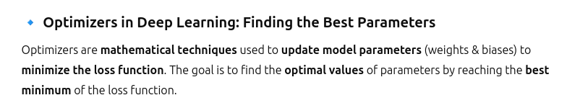
  - Nueral network is an optimisation problem.
  - We optimise the loss generated. We get the optimum values of weights and biases.
  - 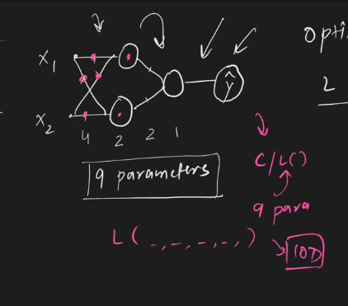
    - Here the loss is a function of 9 differeent parameters,so it is a 9D graph.
    - 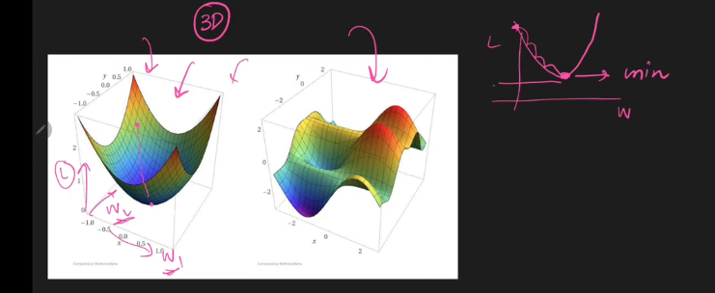
    - Our main goal is we have to travel using randomly generateed weights till I reach the optimum points, optimum weights and parameters.
    - 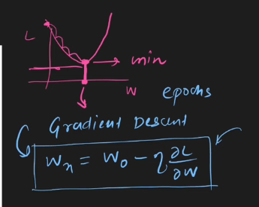
    - One of the optimizers we are using in deep learning is Gradient descent.
    - 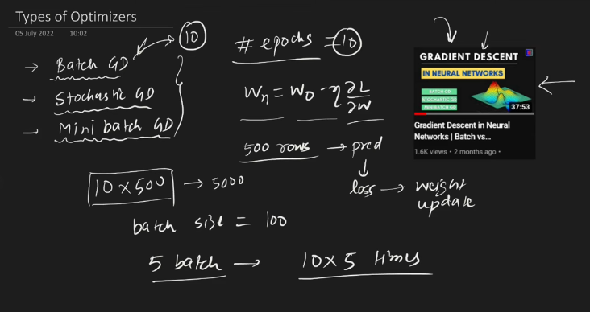
    - Above are 3 optimisers

  - Challenge of using GD:
    - Learning rate fixing from human side .
    - learning rate scheduling:
      - learning rate automatically scheduled to change its value.
      - But in this we need to predefine the values.
      - This is indepednet of the dataset. So getting the great output from it is more challenging.
    - Multiple weights minimisation.
      - We need to travel in many directions.
      - But in all the direction we have the same learning rate, same speed.
      - We need to keep 2 different learning rate, if we are moving in 2dimension, like that if we ahve 9d , we must have 9 different learning rate.
      - This flexibility is not provided by the Gradient Descent.
    - Local minima:
      - There will be multiple minimas.
      - best solution is global minima.
      - But many times we will be stuck at local minima, we cannot come out of the local minima.
      - Except stochastic gradient descent algorithm nobpdy has the ability to come out of the local minima, But stochastic gradintdescent tries to make it by making teh zig zag motion.
    - Saddle point:
      - 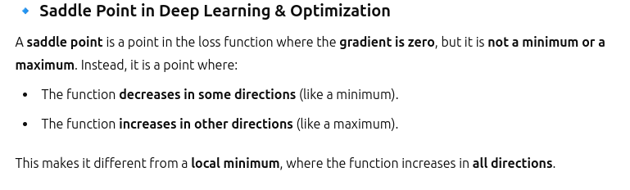
      - 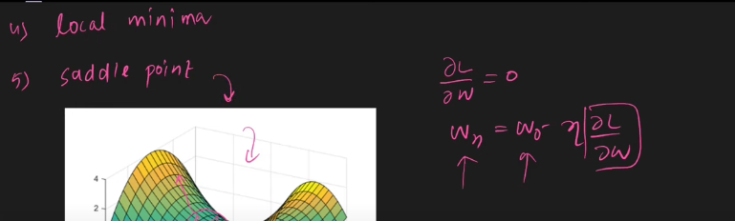
      - Conventioanl gradient will not solve this.
    - Because of this, we do not get the optimum results and training time time increaseases.
  - 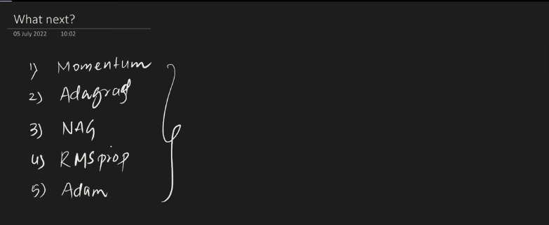

Exponentially weighted moving average:
- This is technique to find the hidden trend in timeseries data.
- 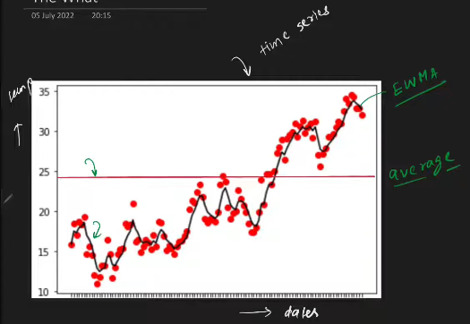
  - black line is exponentially weighted moving avaerage. read line is gloabal average. x axis - dates. y- temp.
- By making the exponentially weighted moving average, we extract the trends in any data. Used at:
  - 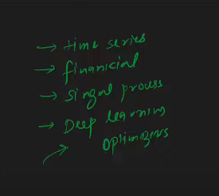
- We give
  - 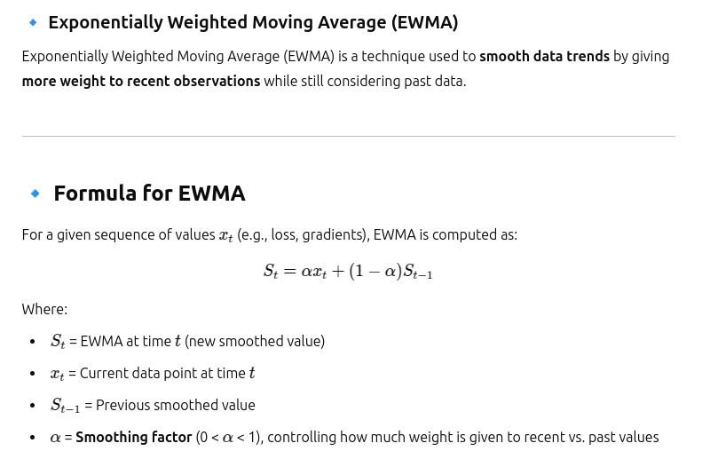
  - We give importance to current or recent once by reducing the weightage to the previous.
  - 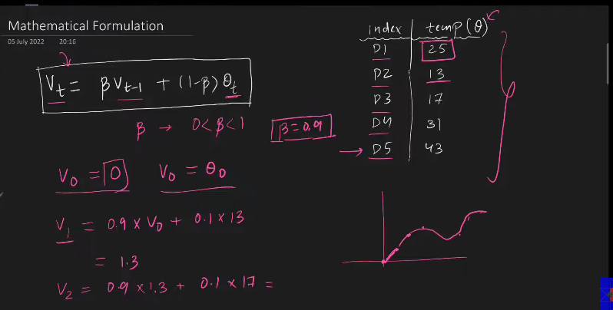
  - When b=0.9, 1/(1-0.9)= 1/0.1 = 10. This means it is behaving like it the 10 previous days average.
  - when b= 0.5, 1/(0.5) = 2, at any point the exponentially weighted moving average acts as the normal average of previous 2 days.
  - By changing the value of b, EWMAs behaviour is getting changed.
  - 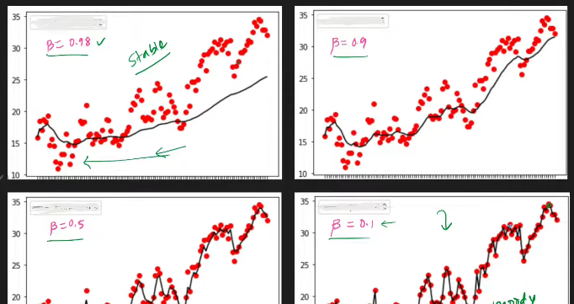
  - If we keep the value of beta very low, then it behaves / gives more importance to current day/ recent data.
  - sweet spot , beta =0.9 . This is what used in the deep learning.
  - 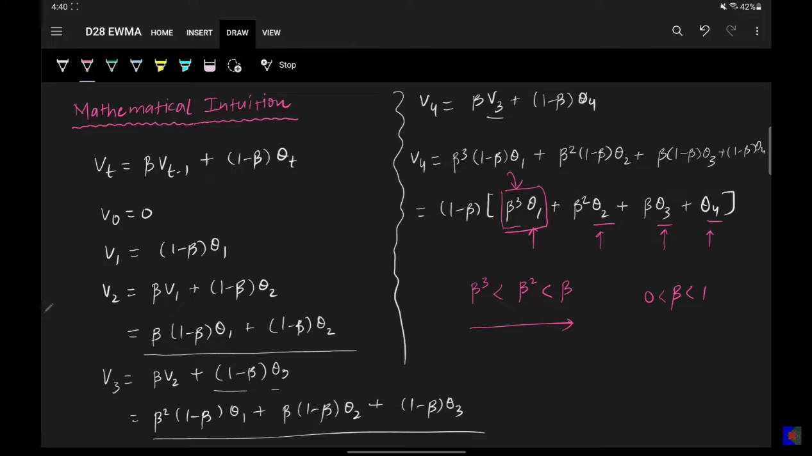
  - Formula is desgigned such a way that it has to give less weoght to the previous points and more weoghts to teh current.

- SGD with momentum
  - 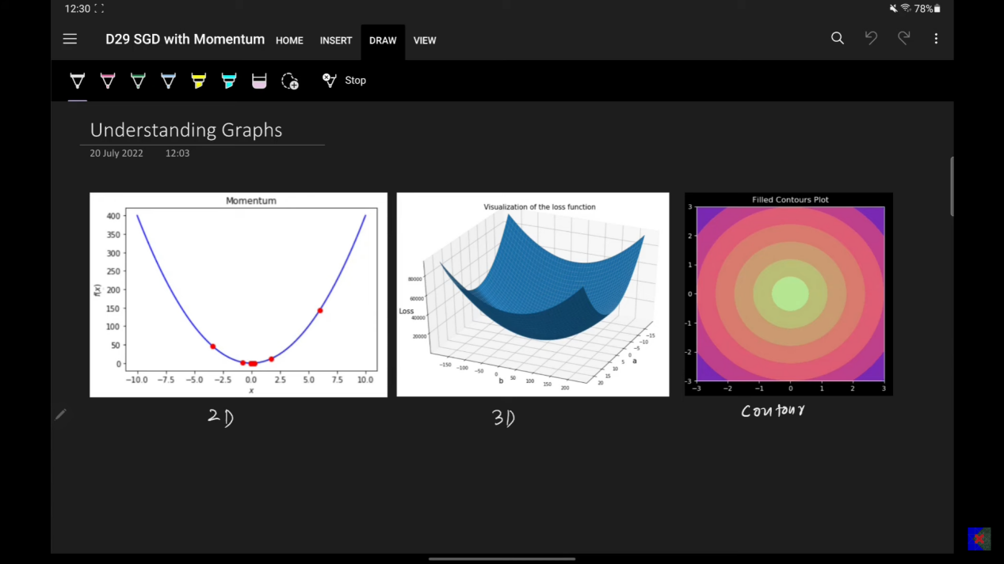
  - 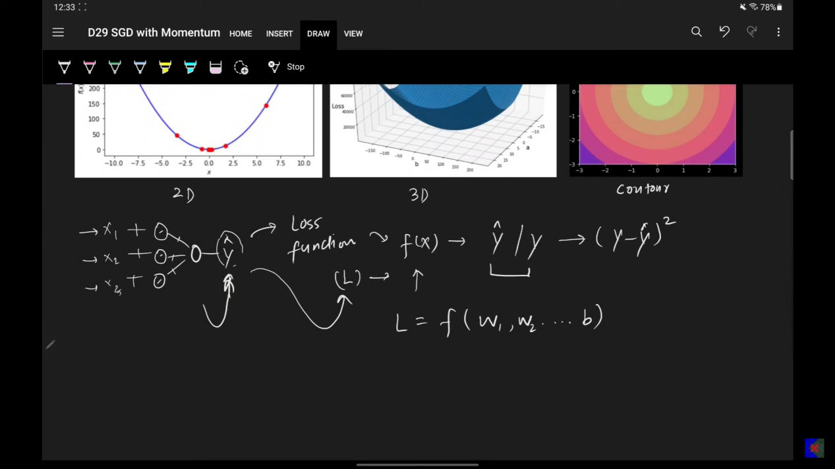
  - 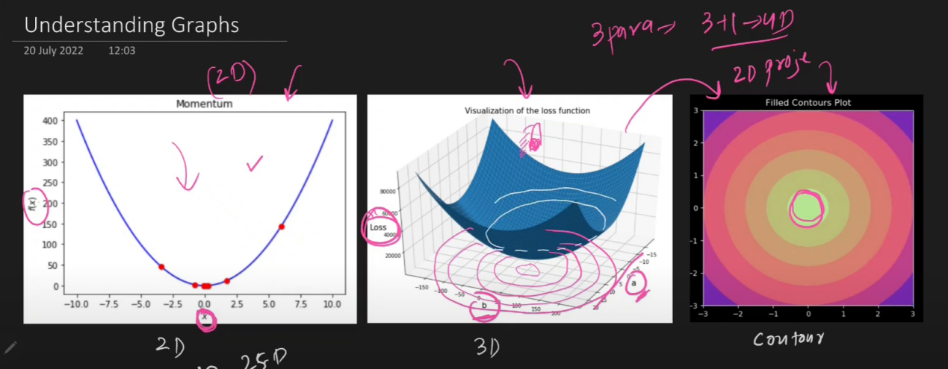
  - When converting from 3d to 2d, we are lose the information to say the information loss is not there, we will be using throgh color.
  - Flat surface, means concntirc circles are away from each other. 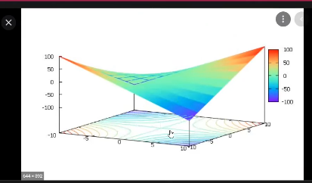
  - 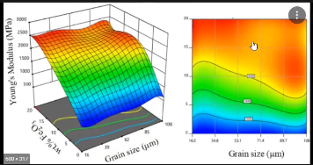
  - 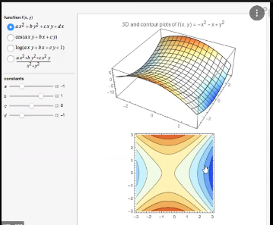
    - Blue is minima, oange is maxima.
  - 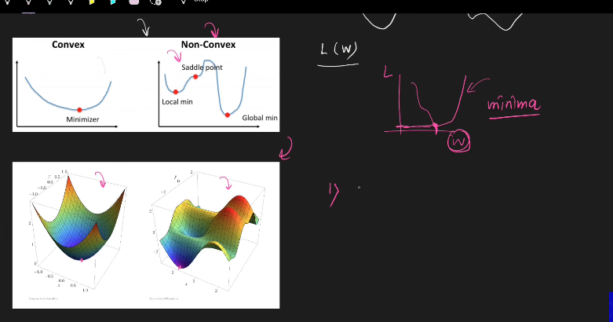
  - Suppose if I’m in non convex region, problem with that is
    - 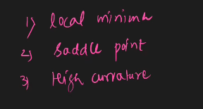
    - Saddle point: For a very long distance the gradient change will be very low. So training time takes too much of time.
    - High curvature:
      - 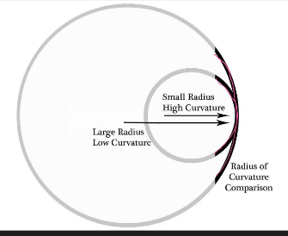
      - Traversing a high curvateure is also a problem, in non convex region.
    - These are the 3 things, Gradient descent will not be able to come with a solution.
- Momentum optimisation
  - 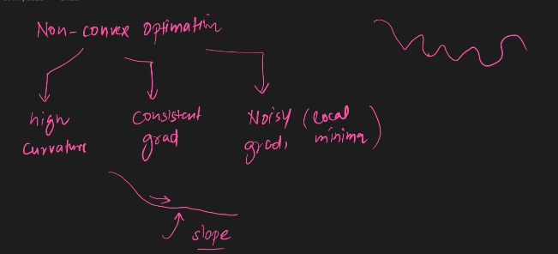
  - Momentum, all the above 3 preoblems can be handled properly.
  - Suppose I’m travelling ffrom A to B. I asked for where is B, all whom we met at the intermediate will all tell to go in the same way so what we do is, we travel very fastly. that is as we go down the curve, we gain more momenutum.
    - History is used in oreder to build teh momentum
      - 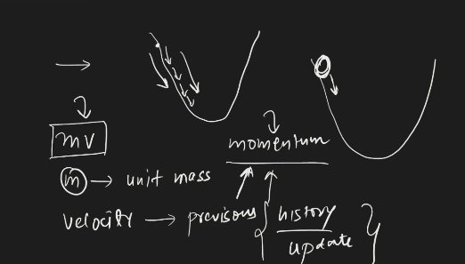
    - 99% it is faster than GD.
  - GD
    - 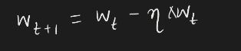
  - Momentum
    - 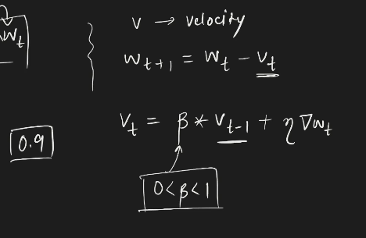
    - 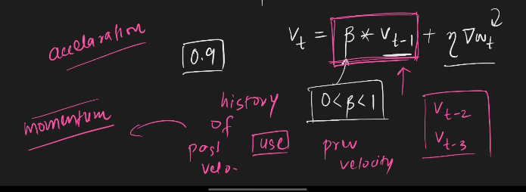
    - 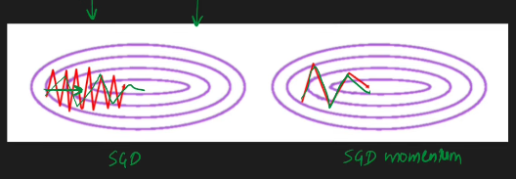
    - Zig zag moment in vertical is reduced and step in horizontal is increased. Faster convergence.
    - Beta =0, sgd becomes
      - Momentum is the newtons momentum.

      - 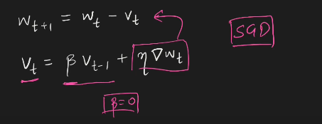
      - beta is decaying factor:
        - beta deteremines, what is the past velocities contribution in the momentum.
        - impact, if the previous velocities is less and the recent velocities impact is huge.

    - Beta =1.
      - 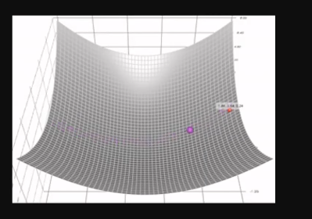
      - There will be no decay.
      - 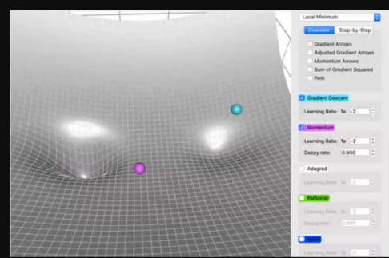
      - Blue is SGD, purple is momentum.
      - 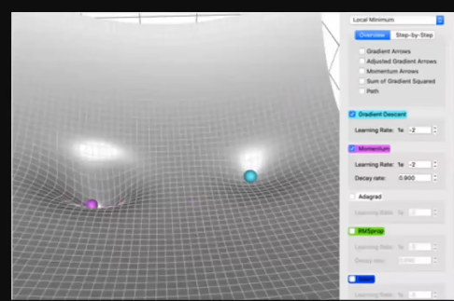
      - Momentum is faster than SGD.
      - Momentum can escape local minimum. Since momentum has momentum, it can overcome the local minima.
    - Problem with the momentum
      - 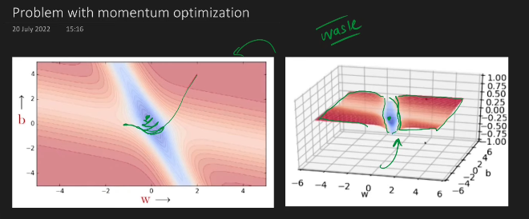
      - TIme waste is more since it is going to stuck in the global minima. When the decay factor is given as 0.9. oscialltion will be more compared to the others. because of the decay factor.
      - 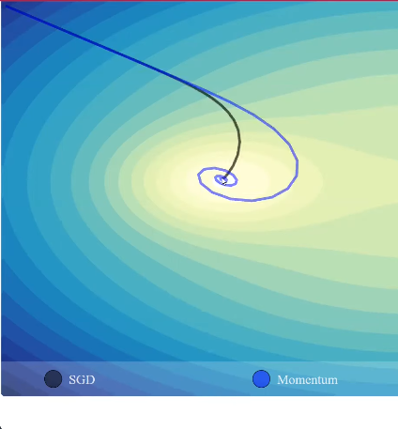
      - This is the visaulaisation tool, whcih speaks about the oscillation of SGD and Momentum, but still momentum is going to reach the global minima. And time taken will be much more comparitively.
      - 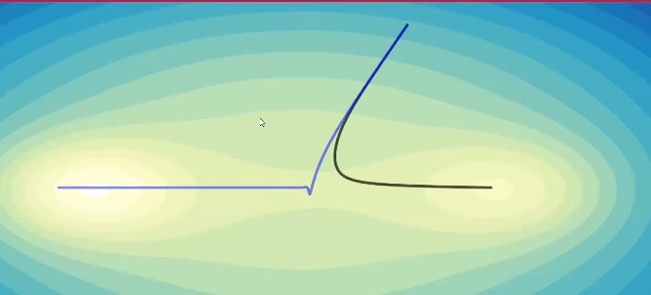
      - 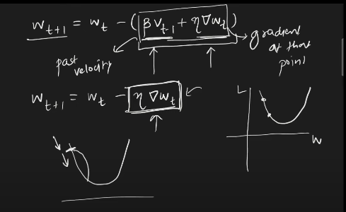
      - Beta part what we are looking at is making the momentum, so when we are on the left part pf the convex, it pushed to go fast towrds minima , that is towards right. When I’m in right side of the graph that is used in order to push the gradient towards the left, towrds the minima point.

Nesterov Accelaerated Gradient(NAG):
- Just look at this video, when looking at this document, in campusx dl playlist.

- 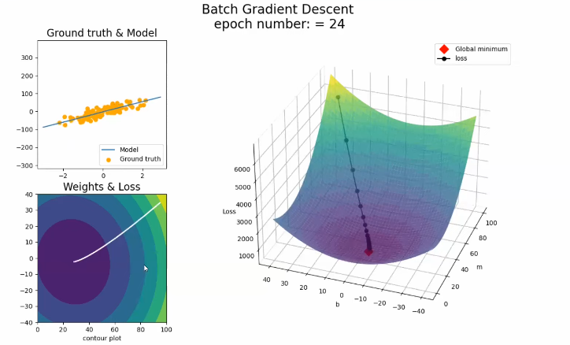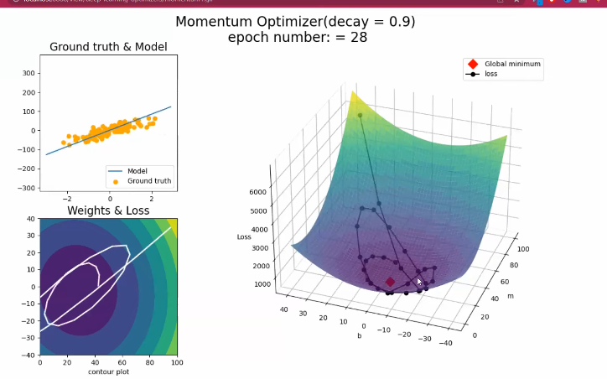
- 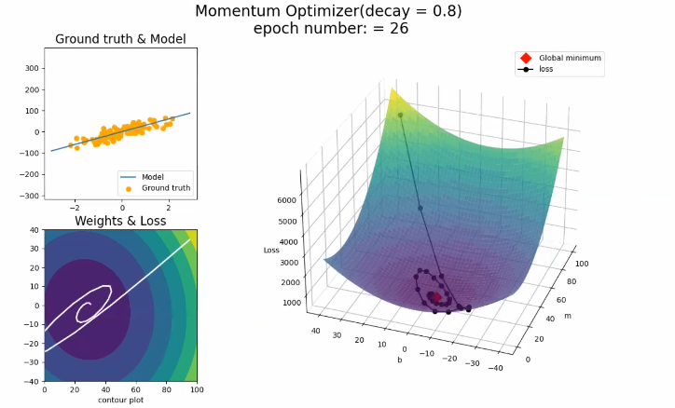
- 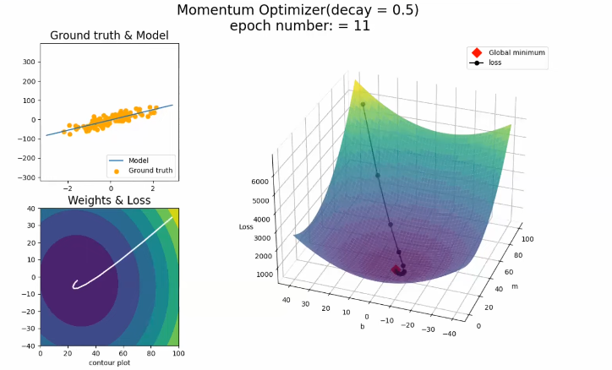
  - So decay factor with momentum is much faster than batch gradient descent.
  - Problem with the momentum is oscillations.
  - When there is non convex error surface, this oscillation will take too much of time to converege. Compared to others.
  - To solve the above we are into Nesterov AG.
  - 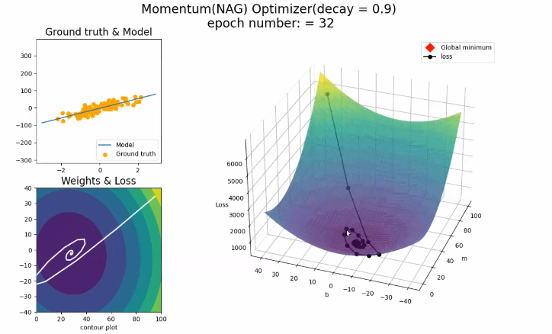
  - Compare this with the previous momentum with the decay factor.The oscillation of NAG is very low cpmpared to the other oscillation.

  - NAG is updated version of the Momentum, but the number of oscillation will be damped.
  - 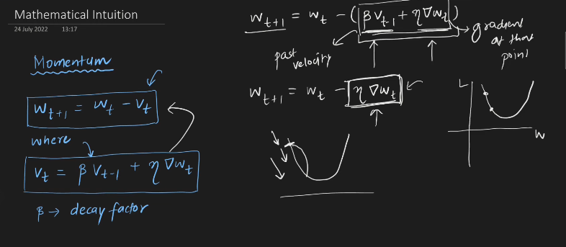
  - The only update is, the gradient update is happeining at which position?? Is NAG.
  - 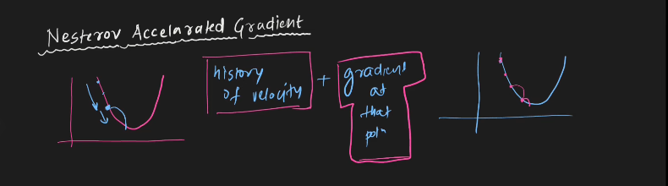
  - In momentum SGD, we calcaulate the momentum and as well as the gradient, at a time we update the parameters.
  - But in the NAG, we calculate above things sepeartley.
    - First I calculate the momentum, then I make the move.
    - Look ahead; After that, wherever it reached, it will calculate the gradeint again, then it is moved to the step.
  - 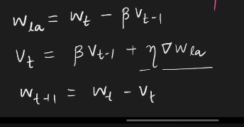
  - 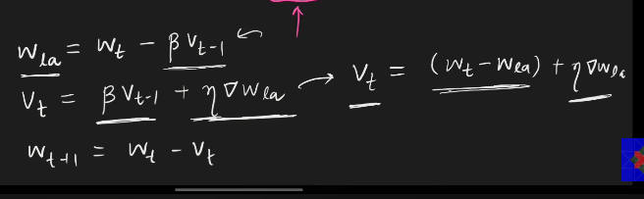
  - 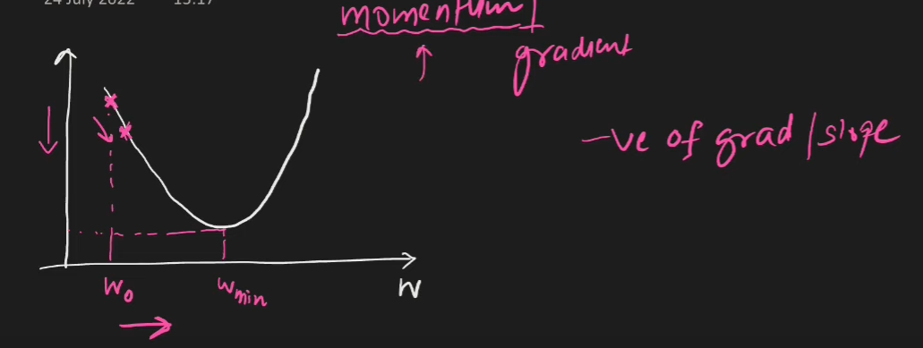
  - First calculated is momentum and then computed is gradeint.
  - 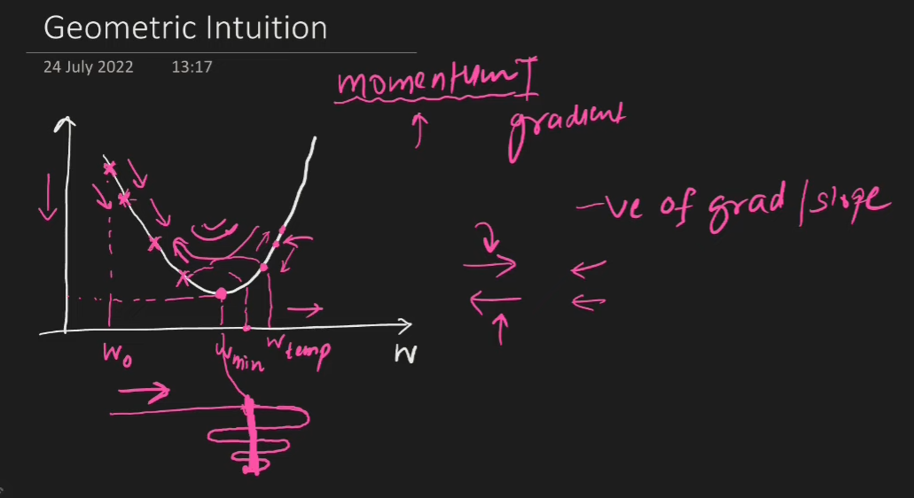
  - This is how momentum works.
  - 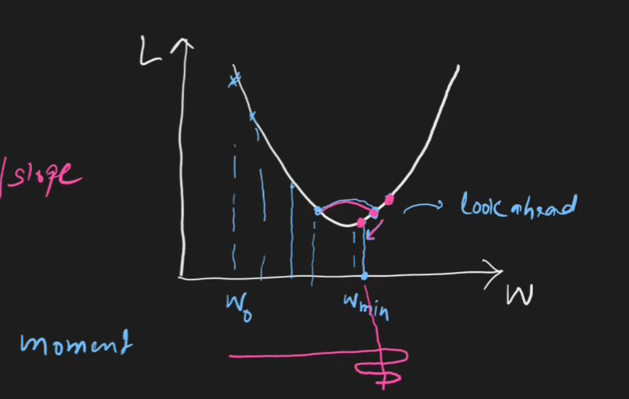
  - This is how nesterov works.
- problem with the Nesterov:
  - Oscillation is dampened. hence there is chance of stucking at the the local minima.
  - 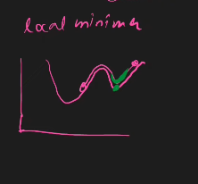
  - Green is the NAG, pink is momentum with SGD, on the surface of the error surface.
  - 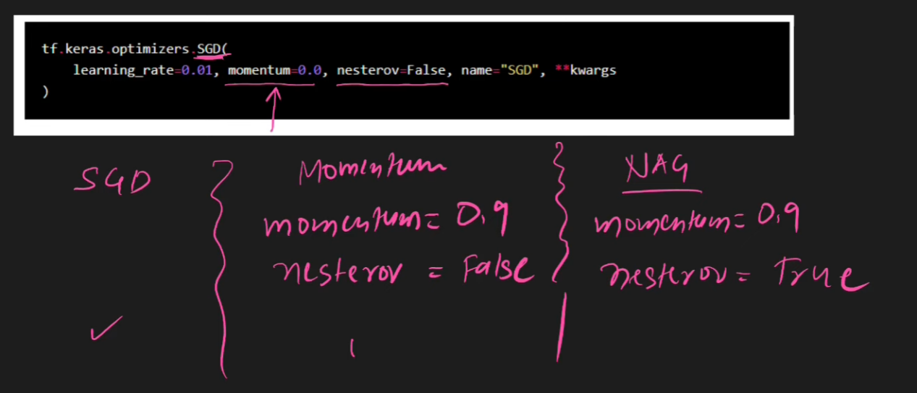
  - SGD, momentum = 0.

ADA-GRAD(Adaptive gradient)
- Learnng rate is not fixed, it keeps changing based on the application.
- 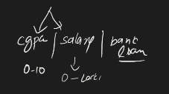
  - On this kind of dataset, the performnace of the adagrad will be great.
  - But whn cpme to this ind of data, usually we normalise the input, hence it is not feasible set of data.
- Suppose if the features are sparse(Most of the vaues are zero), adagrad performs well.
  - 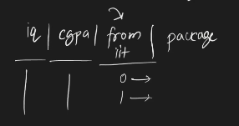
  - When sparse is there, there is elongated bowl problem.
    - 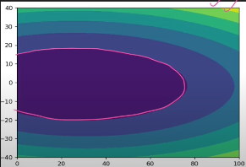
    - This is for sparse input
    - 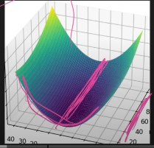
    - We do not move in both the directions, on one directions, the movement is stagnant, the line that is drawn horizontally.
    - Movement is there only one one direction.
    - 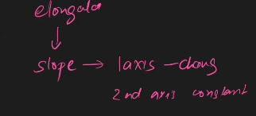
    - BGD, Nag, mometum do not work well here, so ADAGRAD works well here.

  - 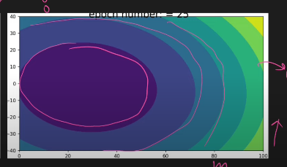
    - This is for non elongated bowl, the most of the values in the x is non zero, weights and biases are taken as the parameter of the loss function.
    - 3d
    - 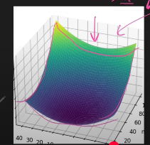
    - we move in both the directions.

  - 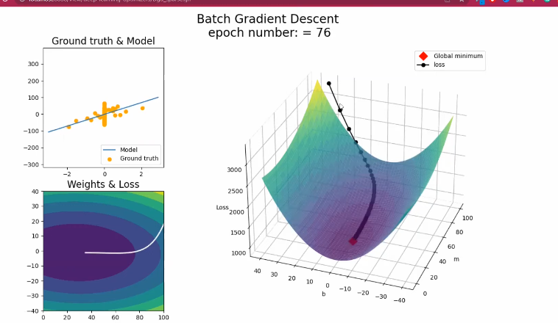
    - The straight line from the point to the optimum point fif there, then SGD was enough, it is wasting time.
    - m is the coffeeicent correspoding to x, x is sparse . b is not sparse, hence theer is high movement in the b direction.
  - Momentum
    - 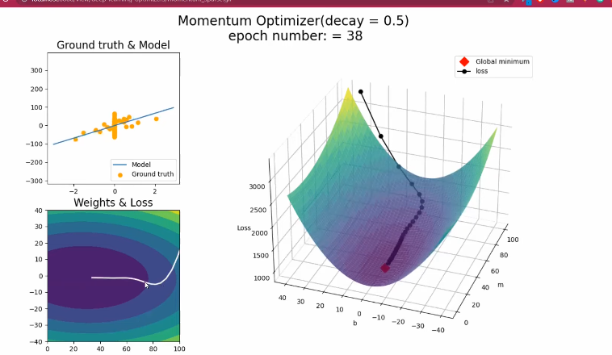
    - Look at 2d graph, it is overshooting. elbow.
    - Not the right way o reach the minima.
    - straightline would be good.
  - 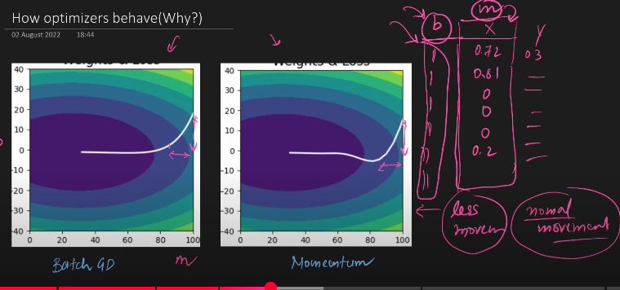
    - on the side of sparse there will be less movement. On the side of non sparse there will be more movement.
    - There is high movment in the side of b, less movement in teh side of m , since m is related to sparse. SO the respective derivative becomes equal to zero.
    - Question: Why there is significant movement on one side ad not on other side?
      - that firstly the update in normal feature which is "b" in your case is more significant than update of "m" but once it reaches to its optimum value then the change in weight in b is near to zero whereas m has not reached to its optimum value. So, it still tries to get its optimum value and continue to change even with small change in weight and thus take large time but still converge.

  - 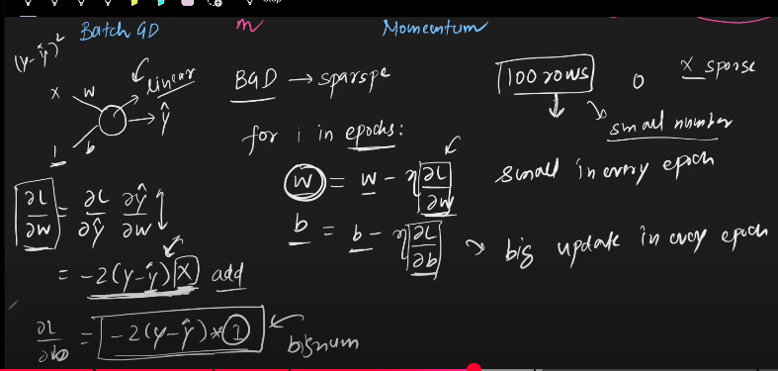

  - The movement is the combination of both side movement.

- Solution to above problem;
  - Derivative smaller, bigger learning rate.
  - Bigger derivative , smaller learning rate.
  - derivative - gradient.
  - formula;
    - 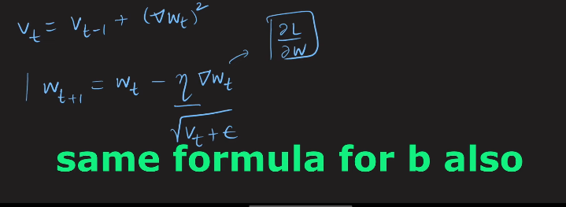
    - 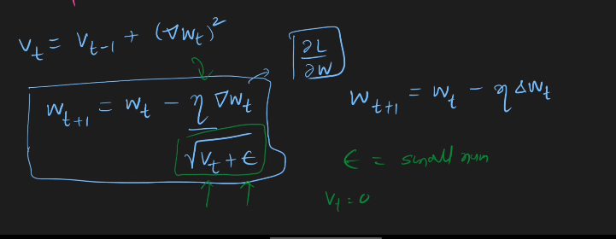
    - Vt - is the sum of the previous gradients square.
    - Squared - the gradients can be both negative and positive, but we need to store it by making it positive before adding it.
      - So making it to consider only the magnitude not the direction.
    - Why not mod,
      - because at the time of back propagation, need to calculate the gradients. Differentiataion needed.
    - 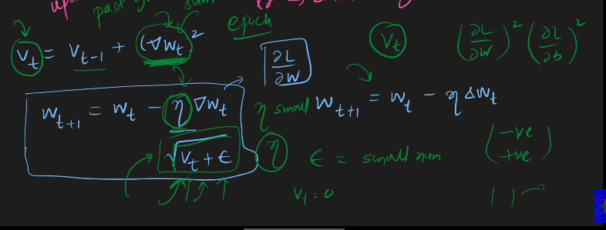

  - 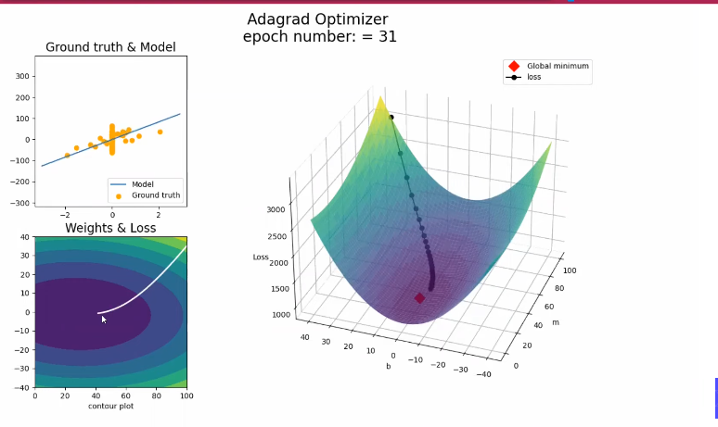
  - Compare the 2d graphs of this with other, do nor have elbow like structure.
- Disadvantage: Bigger, Not use in NN, only in simple Linear regression, not complex LR
  - It comes near the solution , but do not converge :
    - Dividing with vt.
    - Vt value increases as the time progres
    - So when the vt increaes, learning rate will be nearly equal to zero. so it will not conerege to solutions/global mimima.
    - Update of parameters will nothappen at all, after a time.
  - DO not work in complex nueral network, non convex optimisation.
- works properly with simple Nueral networks , simple linear regression , work convex functions.
- Donot converge in convex functions.

RMS prop(Root mean square Prop)
- Improvement of adagrad(Used in sparse dataste, elongated contour plot).
- The above disadvantage was reduced here.
  - 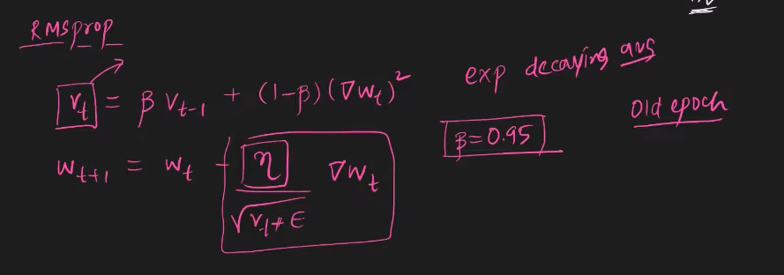
  - 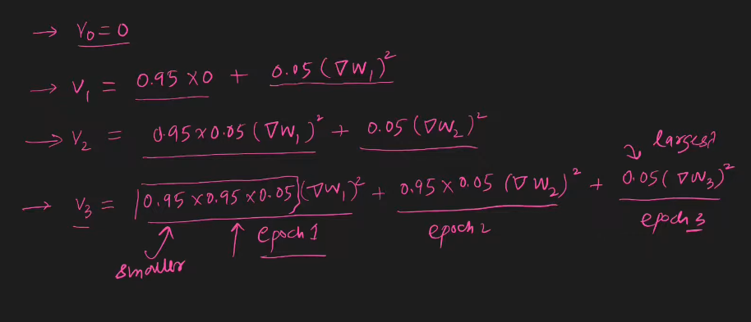
  - This will not stop at any time, it will converge .
- This is used to overcome the adagrads disadvantage.
- 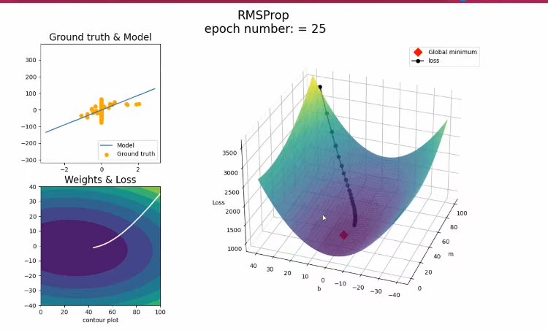
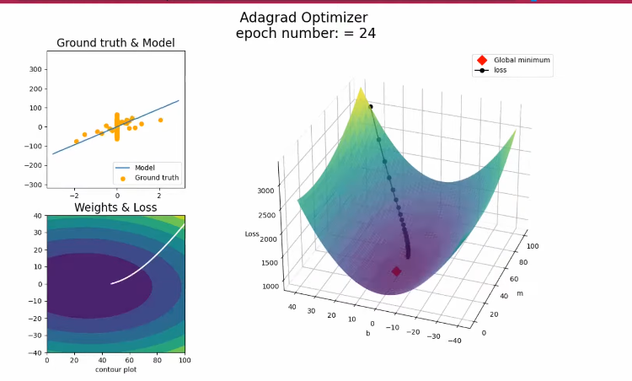

- It is less than the adam, but nothing problem. No disadvantage.

ADAM optimizer(Adaptive Moment Estimation)
- The most powerful.
- It is the combination of all the previous examples.
- Principle behind Adam:
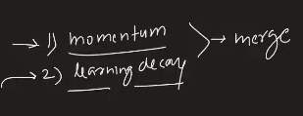
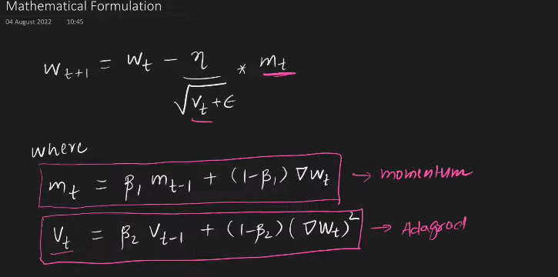
After this we need to do make the bias correction.
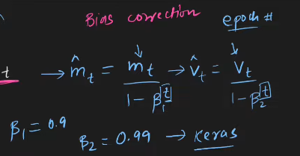
t is called the epoch, the one which are at the bottom.
Intially the b=0, m=0. So we make the bias correction and weight correction.
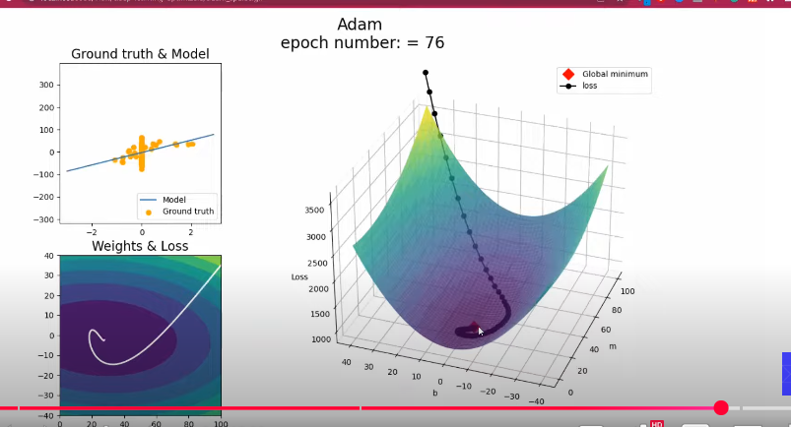
It is the combination of momentum and adagrad.
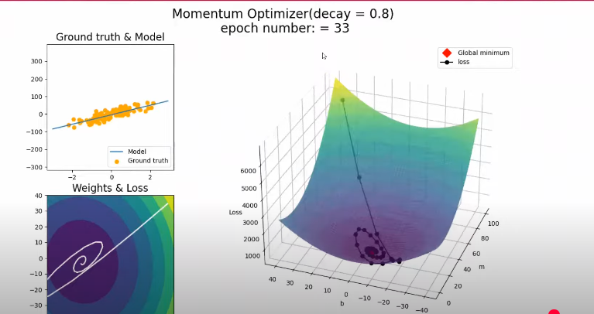
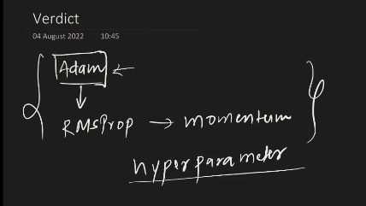
Start with adam, then keep changing to other, check with others.

- s

- s

